- Create one Bash script to check if a directory is available or not.
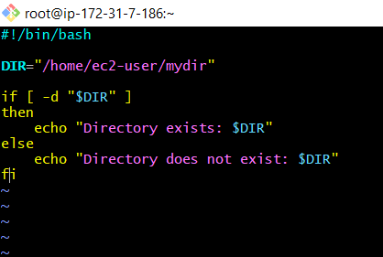
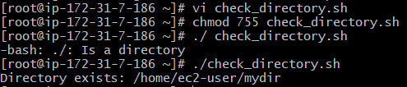

- Create a Bash script which will create multiple files.
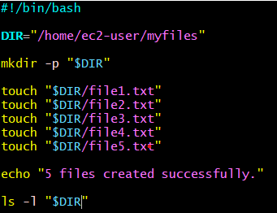
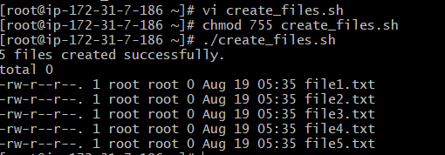

- Create a Bash script to take backup of a directory.
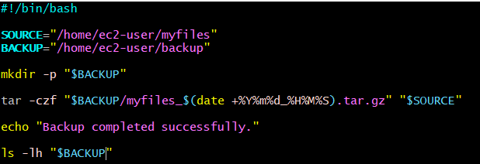
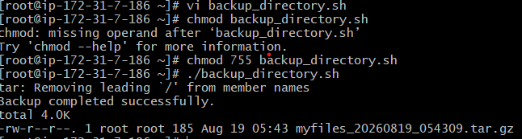
- Create a Bash script to install nginx in an EC2 server.
-created
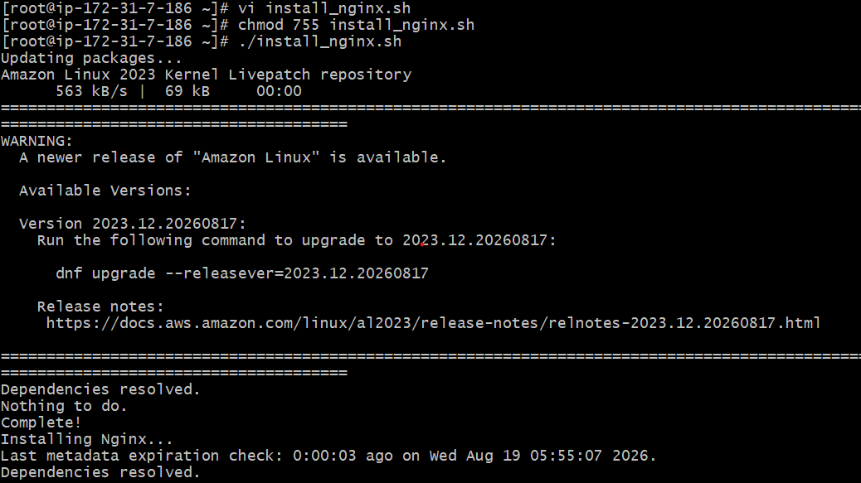
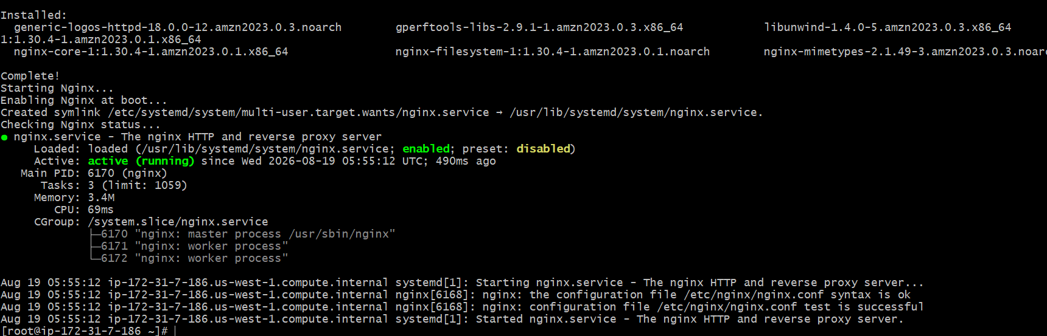
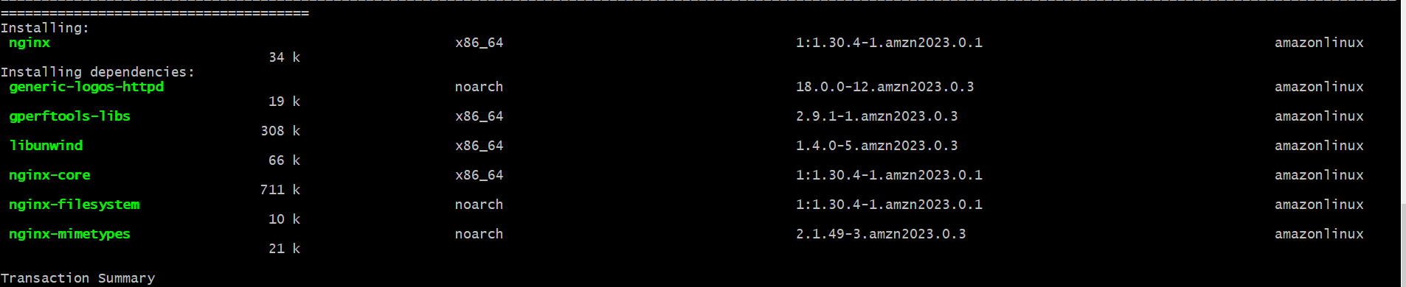

- Create a Bash script to install Apache Tomcat in an EC2 server.
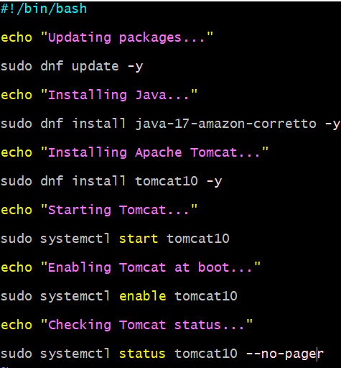
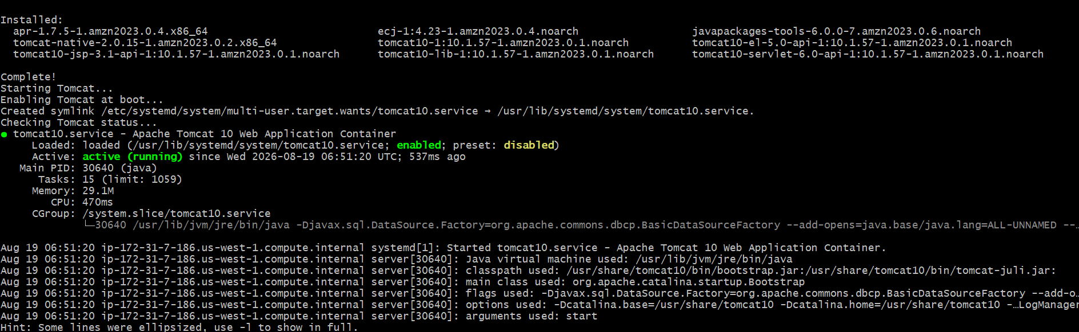

- Create a Bash script to check if nginx service is running or not.
  - If not running, the script should start the service.
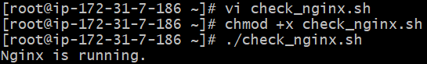
- Create a Bash script to check if a directory is available or not.
  - If not, then create the directory.
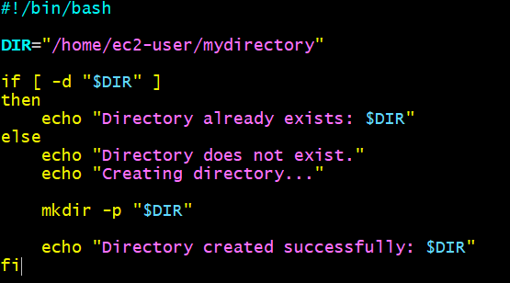
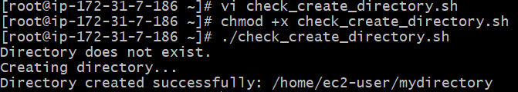

- Create a Bash script to delete the last 3 lines from a file.
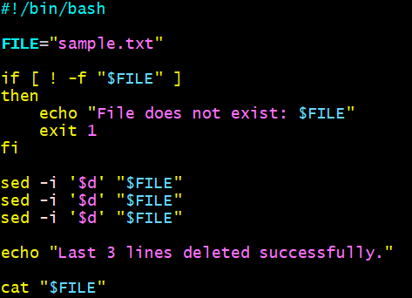
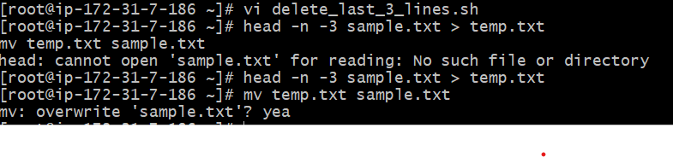

- Create a Bash script to monitor CPU usage.
  - If CPU > 80%, then send an email notification.
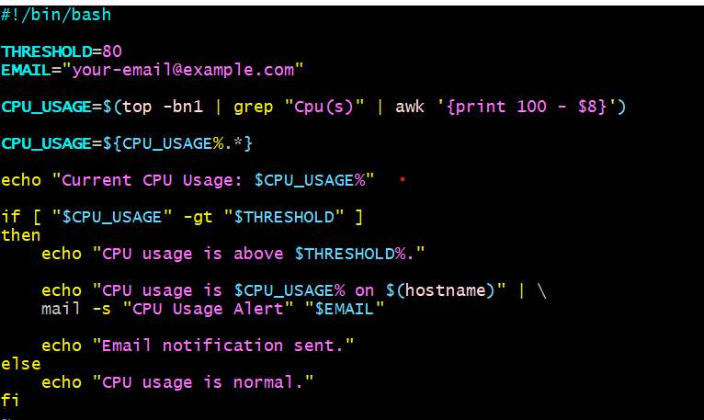
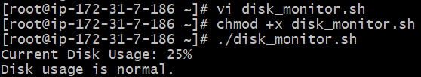

- Create a Bash script to monitor Disk Space.
  - If usage > 80%, then send an email notification.
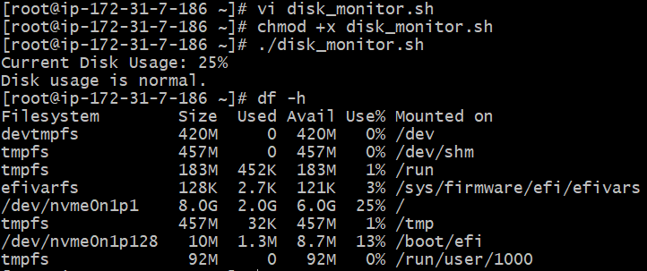

- Create a Bash script to monitor Memory Usage.
  - If usage > 80%, then send an email notification.
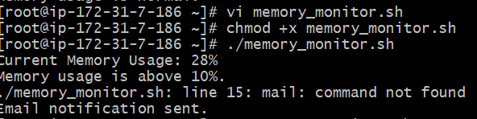m

